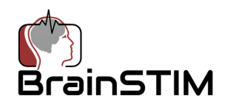
Date:

We cordially invite you to attend the 6th Annual Brain Stimulation and Imaging Meeting (BrainSTIM 2020 meeting https://www.brainstim-meeting.org/ ) which will be held May 20-21, 2020 at Aalto University in Espoo Finland.
Like its predecessors, BrainSTIM 2020 will focus on the combination of brain imaging and stimulation. The meeting will have keynote lectures by leaders in the fields of imaging and stimulation, oral sessions selected from submitted abstracts, poster sessions and other opportunities to network. The meeting is designed to inform and educate all who are interested in these topics, from novices to experts.
This invitation does not include any financial support for travel, registration fees or local expenses.
Please feel free to inform us if you have any questions and/or additional requests. We look forward to seeing you in Espoo, Finland.
Vincent Clark Risto Ilmoniemi
Vincent P. Clark, PhD Risto Ilmoniemi, PhD
Committee Co-Chair BrainSTIM 2020 Committee Co-Chair BrainSTIM 2020

